UNIT 1
Introduction to Operating System

The Operating System is a program with the following features −
- An operating system is a program that acts as an interface between the software and the computer hardware.
- It is an integrated set of specialized programs used to manage overall resources and operations of the computer.
- It is a specialized software that controls and monitors the execution of all other programs that reside in the computer, including application programs and other system software.
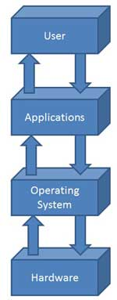

Objectives of Operating System
The objectives of the operating system are −
- To make the computer system convenient to use in an efficient manner.
- To hide the details of the hardware resources from the users.
- To provide users a convenient interface to use the computer system.
- To act as an intermediary between the hardware and its users, making it easier for the users to access and use other resources.
- To manage the resources of a computer system.
- To keep track of who is using which resource, granting resource requests, and mediating conflicting requests from different programs and users.
- To provide efficient and fair sharing of resources among users and programs.

Characteristics of Operating System
Here is a list of some of the most prominent characteristic features of Operating Systems −
- Memory Management − Keeps track of the primary memory, i.e. what part of it is in use by whom, what part is not in use, etc. and allocates the memory when a process or program requests it.
- Processor Management − Allocates the processor (CPU) to a process and deallocates the processor when it is no longer required.
- Device Management − Keeps track of all the devices. This is also called I/O controller that decides which process gets the device, when, and for how much time.
- File Management − Allocates and de-allocates the resources and decides who gets the resources.
- Security − Prevents unauthorized access to programs and data by means of passwords and other similar techniques.
- Job Accounting − Keeps track of time and resources used by various jobs and/or users.
- Control Over System Performance − Records delays between the request for a service and from the system.
- Interaction with the Operators − Interaction may take place via the console of the computer in the form of instructions. The Operating System acknowledges the same, does the corresponding action, and informs the operation by a display screen.
- Error-detecting Aids − Production of dumps, traces, error messages, and other debugging and error-detecting methods.
- Coordination Between Other Software and Users − Coordination and assignment of compilers, interpreters, assemblers, and other software to the various users of the computer systems.

An operating system is a program that acts as an intermediate part between a user of a computer and the computer hardware and controls the execution of all kinds of programs.An operating system is the program that, after being initially loaded into the computer by a boot program, manages all the other programs in a computer.
Objectives of OS:
1.Convenience: An OS makes a computer more convenient to use.
2.Efficiency: An OS allows the computer system resources to be used in an efficient manner.
3.Ability to evolve: An OS should be constructed in such a way as to permit the effective development, testing, and introduction of new system functions without interfering with service.
Functions of an operating System are as follows:
Memory Management: Memory management refers to management of Primary Memory or Main Memory.An Operating System does the following activities for memory management: OS Keeps tracks of primary memory, i.e., what part of it are in use by whom, what part are not in use.In multi-programming, the OS decides which process will get memory when and how much.OS allocates the memory when a process requests it to do so. It de-allocates the memory when a process no longer needs it or has been terminated.
Processor Management: In multi-programming environment, the OS decides which process gets the processor when and for how much time. This function is called process scheduling. An Operating System does the following activities for processor management: OS keeps tracks of processor and status of process.OS allocates the processor (CPU) to a process.It de-allocates processor when a process is no longer required.
Device Management: An Operating System manages device communication via their respective drivers. It does the following activities for device management: Keeps tracks of all devices. The program responsible for this task is known as the I/O controller. Decides which process gets the device when and for how much time. OS allocates the device in the most efficient way.It de-allocates devices in most efficient way.
File Management: A file system is normally organized into directories for easy navigation and usage. These directories may contain files and other directions.An Operating System does the following activities for file management: Keeps track of information, location, uses, status etc. The collective facilities are often known as file system. OS Decides who gets the resources.It allocates the resources and also de-allocates the resources when not in need.
Security: OS prevents unauthorized access to programs and data.For shared or public systems, the OS controls access to the system as a whole and to specific system resources.
Control over system performance: OS will collect usage statistics for various resources and monitor performance parameters such as response time,Recording delays between request for a service and response from the system.
Job accounting: OS Keeps track of time and resources used by various jobs and users.On any system, this information is useful in anticipating the need for future enhancements and in tuning the system to improve performance and can be used for job accounting purposes.
Error detection & Response: A variety of errors can occur while a computer system is running. These include internal and external hardware errors, such as a memory error, or a device failure or malfunction; and various software errors.In each case, the OS must provide a response that clears the error condition with the least impact on running applications. The response may range from ending the program that caused the error, to retrying the operation, to simply reporting the error to the application,Production of dumps, traces, error messages, and other debugging and error detecting aids.
Booting the computer: Booting is the process of starting or restarting the computer. If computer is switched off completely and then turned on then it is cold booting.If computer is restarted then it is warm booting.Booting of the computer is done by OS.
Coordination between other software and users: An OS enables coordination of hardware components, coordination and assignment of compilers, interpreters, assemblers and other software to the various users of the computer systems.

What is Evolution of Operating Systems?
Operating systems have progressed from slow and expensive systems to today's technology, which has exponentially increased computing power at comparatively modest costs. So let's have a detailed look at the evolution of operating systems.
The operating system can be classified into four generations, as follows:
- First Generation
- Second Generation
- Third Generation
- Fourth Generation

First Generation (1945-1955)

Serial Processing
The evolution of operating systems began with serial processing. It marks the start of the development of electronic computing systems as alternatives to mechanical computers. Because of the flaws in mechanical computing devices, humans' calculation speed is limited, and they are prone to making mistakes. Because there is no operating system in this generation, the computer system is given instructions that must be carried out immediately.
Programmers were incorporated into hardware components without using an operating system by the 1940s and 1950s. The challenges here are scheduling and setup time. The user logs in for machine time by wasting computational time. Setup time is required when loading the compiler, saving the compiled program, the source program, linking, and buffering. The process is restarted if an intermediate error occurs.
Example: Windows 95 and 98 are examples of serial processing operating systems.

Second Generation (1955-1965)

Batch System
The batched systems marked the second generation in the evolution of operating systems. In the second generation, the batch processing system was implemented, which allows a job or task to be done in a series and then completed sequentially. The computer system in this generation does not have an operating system, although various operating system functionalities are available, such as FMS and IBSYS. It is used to improve computer utilization and application. On cards and tapes, jobs were scheduled and submitted. Then, using Job Control Language, they were successively executed on the monitors. The first computers employed in the batch operation method created a computer batch of jobs that never paused or stopped. The software is written on punch cards and then transferred to the tape's processing unit. When the computer finishes one job, it immediately moves on to the next item on the tape. Despite the fact that it is inconvenient for the users, it is designed to keep the pricey computer as busy as possible by running a leveraged stream of operations. Memory protection prevents the memory space that makes up the monitor from being changed, and the timer prevents the job from monopolizing the system. When the input and output devices are in use, the processor remains idle due to poor CPU utilization.
Example: MVS Operating System of IBM is an example of a batch processing operating system.

Third Generation (1965-1980)

Multi-Programmed Batched System
The evolution of operating systems embarks the third generation with multi-programmed batched systems. In the third generation, the operating system was designed to serve numerous users simultaneously. Interactive users can communicate with a computer via an online terminal, making the operating system multi-user and multiprogramming. It is used to execute several jobs that should be kept in the main memory. The processor determines which program to run through job scheduling algorithms.
Example: Windows and IOS are examples of multi-programmed batched operating systems.

Fourth Generation (1980-Now)
The operating system is employed in this age for computer networks where users are aware of the existence of computers connected to one another.
The era of networked computing has already begun, and users are comforted by a Graphical User Interface (GUI), which is an incredibly comfortable graphical computer interface. In the fourth generation, the time-sharing operating system and the Macintosh operating system came into existence.
- Time-Sharing Operating System:
The Time-sharing of operating systems had a great impact on the evolution of operating systems. Multiple users can access the system via terminals at the same time, and the processor's time is divided among them. Printing ports were required for programs having a command-line user interface, which required written responses to prompts or written commands. The interaction is scrolled down like a roll of paper. It was previously used to develop batch replacement systems. The user interfaces directly with the computer via printing ports, much like an electric teletype. Few users shared the computer immediately, and each activity was completed in a fraction of a second before moving on to the next. By establishing iterations when they are receiving full attention, the fast server may act on a large number of users' processes at once. Multiple programs use time-sharing systems to apply to the computer system by sharing the system interactively.
Example: Unix Operating System is an example of a time-sharing OS.
- Macintosh Operating System:
It was based on decades of research into graphical operating systems and applications for personal computers. The photo depicts a Sutherland pioneer program sketchpad that was developed in 1960, employing many of the characteristics of today's graphical user interface, but the hardware components cost millions of dollars and took up a room. The initiative on massive computers and hardware improvements made the Macintosh commercially and economically viable after many research gaps. Many research laboratories are still working on research prototypes like sketchpads. It served as the foundation for anticipated products.
Example: Mac OS X 10.6.8 snow leopard and OS X 10.7.5 Lion are some examples of macintosh OS.

- The interface between the user and the computer system is known as an operating system.
- The history of the operating system has 4 generations.
- The first generation (1945-1955) only had computer systems that were used to perform simple mathematical operations and also electronic computers were introduced during the 1940s.
- The second generation (1955-1965) introduced the concept of a Batch operating system.
- In the third generation (1965-1980), multiprogramming was introduced where multiple tasks could be performed on a single operating system.
- In the fourth generation (1980-now) different operating systems like Windows OS and macOS were introduced.
- The operating system helps in regulating and monitor the device, creating an interface between the hardware and the user.
- Backing up your data is necessary because you might lose your data if somehow any error occurs in your system.

Evolution of Operating System

Evolution of Operating System - OS Generations
Before learning about the evolution of operating systems, let us first get a brief understanding of operating systems.
An Operating System is nothing but a software program that acts as an interface between the hardware, the application software, and the users. The main aim of an operating system is to manage all the computer resources, security, file systems, etc. So, we can simply say that the operating system gives a platform to the application software and other system software to perform their task.
Refer to the diagram below to understand the value and working of the operating system.
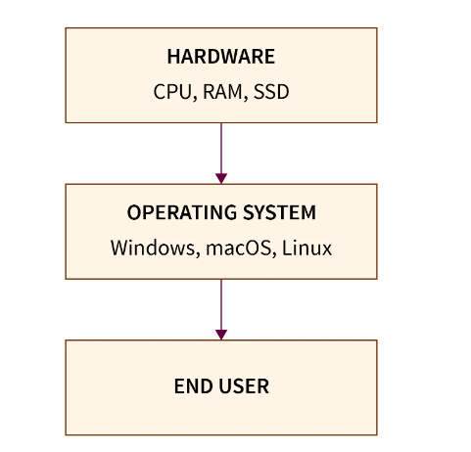
Operating System is not the same as we see today. Let us discuss the evolution of the operating system in detail. In today's world, we can see that a user of the computer directly interacts with the computer. But in the past years, the users were not able to directly interact with the computer system.
From a broader perspective, the evolution of the operating system can be divided into four generations. Let us briefly discuss this generation-based evolution of the operating system with their timeline.
- First Generation. The first generation of the operating system was used in the year 1945 to 1955 during the time of electronic computing systems development. It was the era of mechanical computing systems where the users or the programmers used to provide the instructions (through punch cards, paper tape, magnetic tape, etc.) and the computer had to follow them. Now, due to human intervention, the process was very slow and there were chances of human mistakes.
We can say that there is no operating system at that time and users used to give programs to the computer system itself. So, less speed and more errors were the first-generation operating systems' drawbacks.
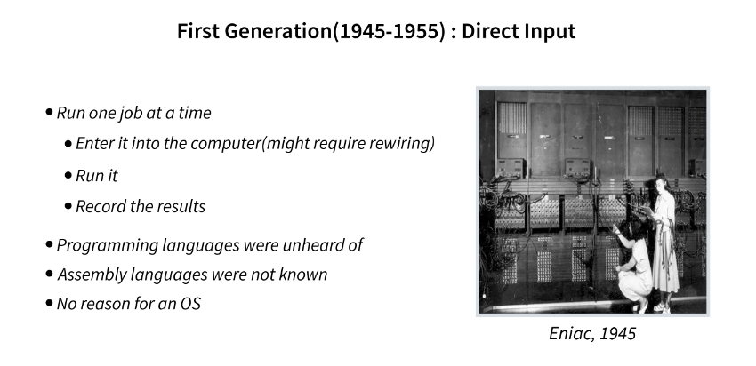
- Second Generation. The second generation of the operating system was used from the year 1955 to 1965 during the time of batch operating system development.
During the second generation phase, the users used to prepare their instructions (tasks or jobs) in the form of jobs on an off-line device like punch cards and submit them to the computer operator. Now, out of these punch cards (these punch cards were tabulated into instructions for computers), similar punch cards of jobs were grouped and run as a group to speed up the entire process. The jobs consisted of program and input data along with the control instructions. The main task of the programmer or developer was to create jobs or programs and then hand them over to the operator in the form of punch cards. Now, it was the duty of an operator to sort the programs with similar requirements into batches.
Some major drawbacks of the second-generation operating system were:
- We could not set the priority of the jobs as jobs were scheduled only basis of similarities among the jobs.
- The CPU was not utilized to its max potential as the CPU becomes idle (when the operator was loading jobs).
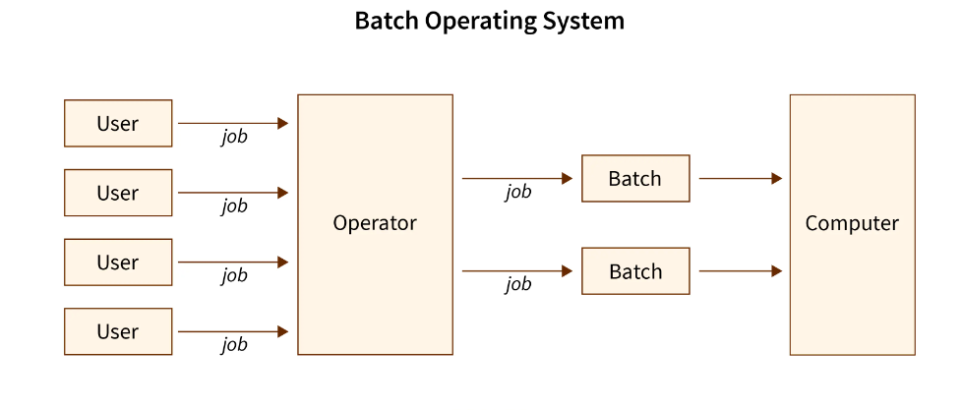
- Third Generation. The third generation of the operating system was used in the year 1965 to 1980 during the time of multiprogramming operating system development. The third generation operating system was developed to serve more than one user at a time (multi-users). During this period, users were able to communicate with the operating systems with the help of software called command-line interface. So, the computers became multi-user and multiprogramming.
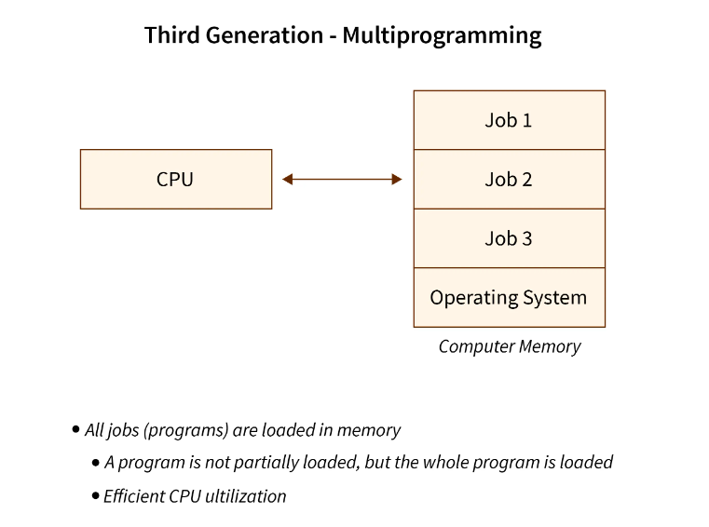
- Fourth Generation. The fourth generation of the operating system is being in from the year 1980 till now. Before the evolution of the fourth generation of the operating system, the users were able to communicate with the operating system but with the help of command line interfaces, punch cards, magnetic tapes, etc. So, the user had to provide commands (that needed to be remembered) which became hectic.
So, the fourth generation of operating systems came into existence with the development of GUI (Graphical User Interface). The GUI made the user experience more convenient.
We can also terminate the fourth generation operating system era the era of the distributed operating systems. Now, the operating systems can be found in mobile devices, smartwatches, fitness bands, smart glasses, VR gears, and so on. We are now surrounded by various versions of the operating system.
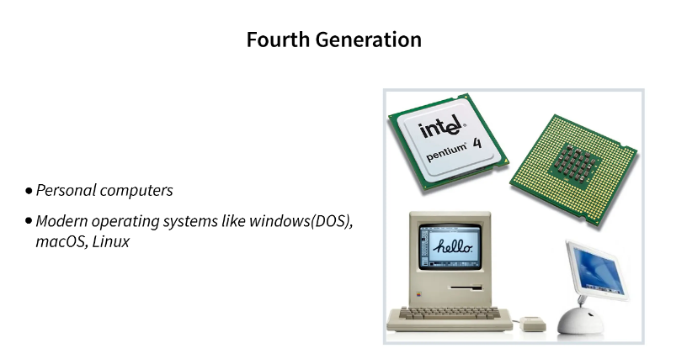

Evolution of Operating System - OS Features
As we have seen the evolution of operating systems based on generation, let us now discuss the evolution of operating systems based on the feature (how features got developed over the years).
Refer to the image below to see the evolution of the operating system over the years.
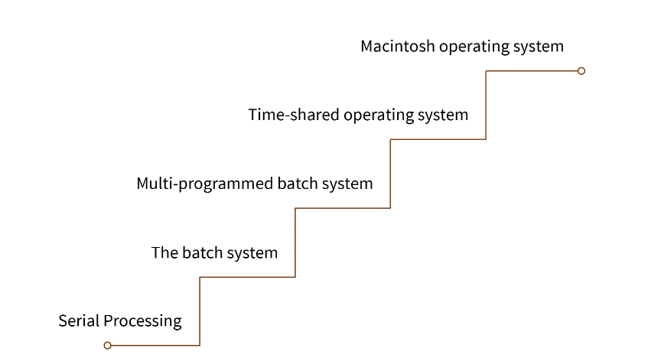

a. Serial Processing
Before the 1950�1950s, there was no operating system, and users used to give programs to the computer system itself. So, less speed and more errors were generated (as serial processing is done on a single machine). So, the developers or the programmers had to provide the entire program in the form of sequential instruction in the form of a punched card. These punched cards were first translated into a card reader and then it was submitted to the operating system.
Due to this extensive process of execution of a simple program and human intervention, the overall execution time was very large and inefficient. There were various other problems such as no user interaction, execution of only one process at a time, very less memory, no error handling, etc. Now, a red light was used to detect the error in the program execution. So, if there was any error, the error got detected due to red blinking lights.
The major drawbacks of the serial operating system were:
- No user and computer system interaction.
- Very less memory.
- It required a lot of time for program execution.
- Only one program could be executed at a time.
- the user could not execute another program when one program was in execution.
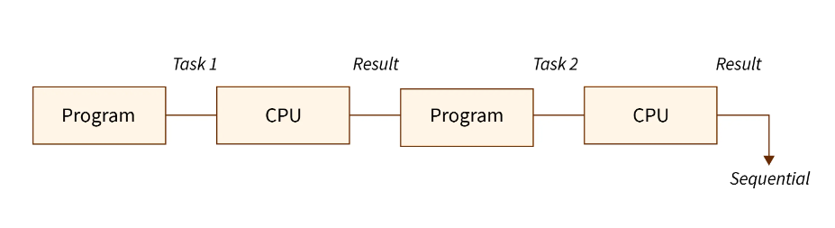

b. Batch Processing
In today's world, we can see that a user of the computer directly interacts with the computer. But in the past years (1955 - 1965), the users were not able to directly interact with the computer system.
In earlier times, we used a type of operating system termed a batch operating system in which the user(s) used to prepare their instructions (tasks or jobs) in the form of jobs on an off-line device like punch cards and submits them to the computer operator. Now, out of these punch cards, similar punch cards of jobs were grouped and run as a group to speed up the entire process.
Note: The Jobs consisted of program and input data along with the control instructions.
The main task of the programmer or developer was to create jobs or programs and then hand them over to the operator in the form of punch cards. Now, it was the duty of an operator to sort the programs with similar requirements into batches. Due to this dual procedure and manual intervention, the batch operating system was a slow operating system. The most common use input and output devices were card-reader or tape drives.
The Batch operating system was used to schedule similar jobs in one batch, so the same jobs in the batch were executed at a higher speed. As the jobs were scheduled one after the other, whenever a job gets completed, the next job from the job spool gets executed without any user interaction. The batch operating system also eliminates the setup time issue.
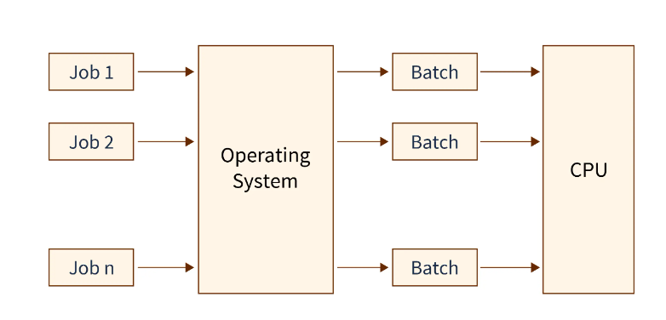
Since the batch operating system was very simple, it always resided in the memory and its major task was to transfer control from one job to another job.
There major drawbacks of the batch operating system were:
- We could not set the priority of the jobs as jobs were scheduled only based on similarities.
- The CPU was not utilized to its maximum potential as the CPU becomes idle when the operator was loading jobs.

c. Multiprogramming
In the multiprogramming operating system, several jobs or processes can be loaded into the main memory simultaneously with the help of a single processor (a single processing unit was there and programs were scheduled on a certain basis). Now, it was the duty of a subpart of the operating system called job scheduler to schedule these processes in such a way that maximum processes can be executed in minimum time. So, better CPU and memory utilization along with the execution of several processes at a time was the main aim of the multiprogramming operating system.
The benefits of a multiprogramming operating system are:
- Multiple processes can be loaded into the main memory.
- The multiprogramming operating system was able to use both primary and secondary memory.
- Users can interact with the processes through input and output devices.
- There was no sequential process execution hence the later processes need not wait for a large amount of time.
- The CPU was better utilized. If there is any process that waits for an I/O, then the CPU will change the job and takes another job from the job pool so that the CPU will never sit idle.
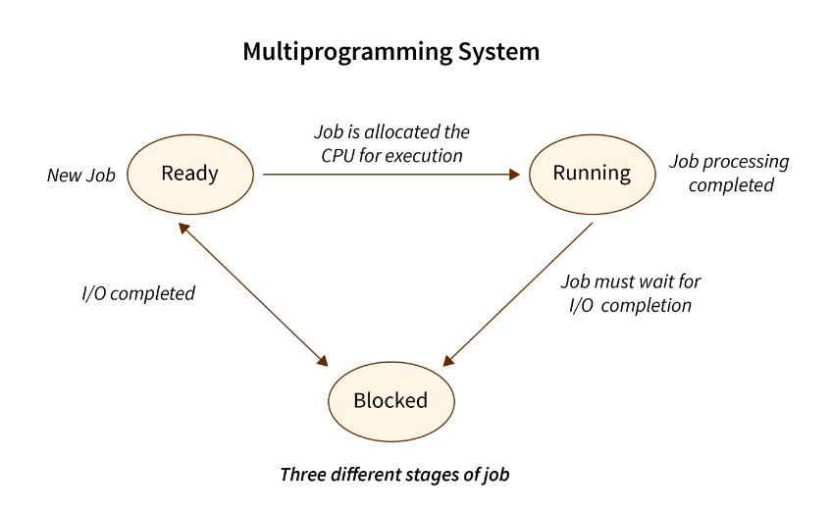

d. Time-sharing System
In the time-sharing operating system, several jobs or processes can be loaded into the main memory simultaneously and several users can share the system as well. We can hence, say that the time-sharing operating system was a logical extension of the multiprogramming operating system. The name time-sharing was used because the processes used to share an equal amount of time specified by the operating system developer.
The main aim of the time-sharing operating system was to reduce the overall process response time. The CPU could execute several processes by providing an equal amount of time to each process, so the CPU utilization became better than the multiprogramming operating system.
Note:
- Response time is the total amount of time it takes to respond to a process. It should not be confused with the execution time. The switching between several operating system processes was handled by an operating system subprocess knew as the CPU scheduler.
The benefits of the time-sharing operating system are:
- Multiple processes and user requests can be responded to simultaneously as there is more than one processing unit.
- Better response time than the previously used multiprogramming operating system.
- The CPU did not have to be idle due to regular switching.
- More efficient utilization of the CPU.
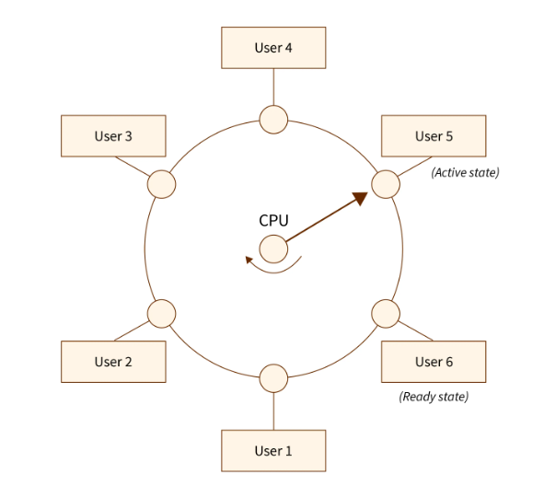

e. Parallel Processing System
In the parallel processing operating system, there we more than one processor. So, several jobs or processes can be loaded into the main memory simultaneously and all the processors work concurrently on these processes. In a parallel processing operating system, a process is divided into several sub-processes (also known as threads), and these threads are distributed for execution among the various processors that are present in the system. There is multiprogramming.
So, the parallel processing finishes the job in lesser time. Now, as multiple processors execute the job in a parallel manner, this system was termed a parallel processing operating system.
The benefits of a parallel processing operating system are:
- Due to multiple processors, a process was executed even faster than the time-sharing operating system.
- If one of the processors failed then the other processors were able to execute the process so there was very less chance of failure.
- The delay in the processing of data was reduced to much extent.
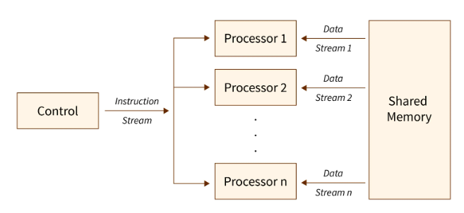

f. Distributed System
In the distributed operating system, two or more nodes are connected. The distributed operating system is also known as the loosely coupled operating system as various nodes are connected, but the memory or a clock is not shared by the processors. These nodes can communicate with each other using telephone lines or high-speed buses, etc.
The benefits of the distributed operating system are:
- If one of the computer systems (nodes) fails then it will not affect the other network communication.
- As the resources of a node are shared, the computation speed became faster, more affordable, and more durable.
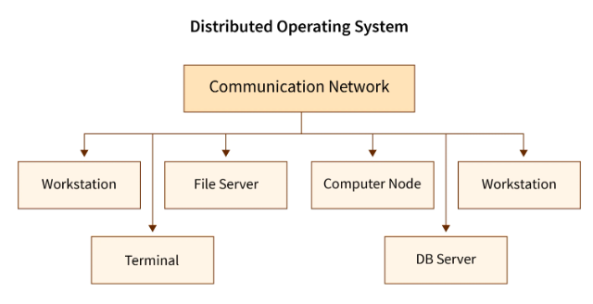

Conclusion
- Initially, the users used to provide the instructions and the computer had to follow them. After some time, the users used to prepare their instructions in the form of jobs on punch cards and submit them to the computer operator.
- After that, users were able to communicate with the operating systems with the help of software called terminal. Nowadays, with the development of Graphical User Interface, the user experience is more convenient.
- Several processes can be loaded into the main memory simultaneously with the help of a single processor in the multiprocessor operating system.
- In a time-sharing system, processes are used to share an equal amount of time specified by the operating system developer.
- In a parallel processing operating system, there we more than one processor. Hence several processes can be loaded into the main memory simultaneously and all the processors work concurrently on these processes.
- In the distributed operating system, two or more nodes are connected. Various nodes are connected, but the memory or a clock is not shared by the processors.

https://www.scaler.com/topics/evolution-of-operating-system/
For challenge

Process in Operating System
A process is a program in execution which then forms the basis of all computation. The process is not as same as program code but a lot more than it. A process is an 'active' entity as opposed to the program which is considered to be a 'passive' entity. Attributes held by the process include hardware state, memory, CPU, etc.
Process memory is divided into four sections for efficient working :
- The Text section is made up of the compiled program code, read in from non-volatile storage when the program is launched.
- The Data section is made up of the global and static variables, allocated and initialized prior to executing the main.
- The Heap is used for the dynamic memory allocation and is managed via calls to new, delete, malloc, free, etc.
- The Stack is used for local variables. Space on the stack is reserved for local variables when they are declared.
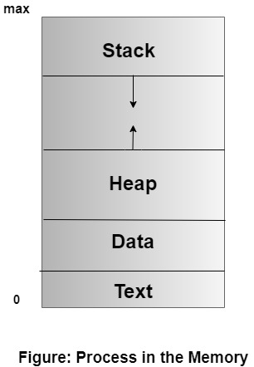

File
A file is a named collection of related information that is recorded on secondary storage such as magnetic disks, magnetic tapes and optical disks. In general, a file is a sequence of bits, bytes, lines or records whose meaning is defined by the files creator and user.

File Structure
A File Structure should be according to a required format that the operating system can understand.
- A file has a certain defined structure according to its type.
- A text file is a sequence of characters organized into lines.
- A source file is a sequence of procedures and functions.
- An object file is a sequence of bytes organized into blocks that are understandable by the machine.
- When operating system defines different file structures, it also contains the code to support these file structure. Unix, MS-DOS support minimum number of file structure.

File Type
File type refers to the ability of the operating system to distinguish different types of file such as text files source files and binary files etc. Many operating systems support many types of files. Operating system like MS-DOS and UNIX have the following types of files −

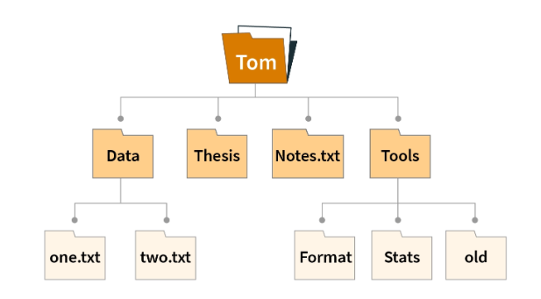

Ordinary files
- These are the files that contain user information.
- These may have text, databases or executable program.
- The user can apply various operations on such files like add, modify, delete or even remove the entire file.

Directory files
- These files contain list of file names and other information related to these files.

Special files
- These files are also known as device files.
- These files represent physical device like disks, terminals, printers, networks, tape drive etc.
These files are of two types −
- Character special files − data is handled character by character as in case of terminals or printers.
- Block special files − data is handled in blocks as in the case of disks and tapes.

File Access Mechanisms
File access mechanism refers to the manner in which the records of a file may be accessed. There are several ways to access files −
- Sequential access
- Direct/Random access
- Indexed sequential access

Sequential access
A sequential access is that in which the records are accessed in some sequence, i.e., the information in the file is processed in order, one record after the other. This access method is the most primitive one. Example: Compilers usually access files in this fashion.

Direct/Random access
- Random access file organization provides, accessing the records directly.
- Each record has its own address on the file with by the help of which it can be directly accessed for reading or writing.
- The records need not be in any sequence within the file and they need not be in adjacent locations on the storage medium.

Indexed sequential access
- This mechanism is built up on base of sequential access.
- An index is created for each file which contains pointers to various blocks.
- Index is searched sequentially and its pointer is used to access the file directly.

Space Allocation
Files are allocated disk spaces by operating system. Operating systems deploy following three main ways to allocate disk space to files.
- Contiguous Allocation
- Linked Allocation
- Indexed Allocation

Contiguous Allocation
- Each file occupies a contiguous address space on disk.
- Assigned disk address is in linear order.
- Easy to implement.
- External fragmentation is a major issue with this type of allocation technique.

Linked Allocation
- Each file carries a list of links to disk blocks.
- Directory contains link / pointer to first block of a file.
- No external fragmentation
- Effectively used in sequential access file.
- Inefficient in case of direct access file.

Indexed Allocation
- Provides solutions to problems of contiguous and linked allocation.
- A index block is created having all pointers to files.
- Each file has its own index block which stores the addresses of disk space occupied by the file.
- Directory contains the addresses of index blocks of files.

What is System Call in Operating System?
A system call is a mechanism that provides the interface between a process and the operating system. It is a programmatic method in which a computer program requests a service from the kernel of the OS.
System call offers the services of the operating system to the user programs via API (Application Programming Interface). System calls are the only entry points for the kernel system.
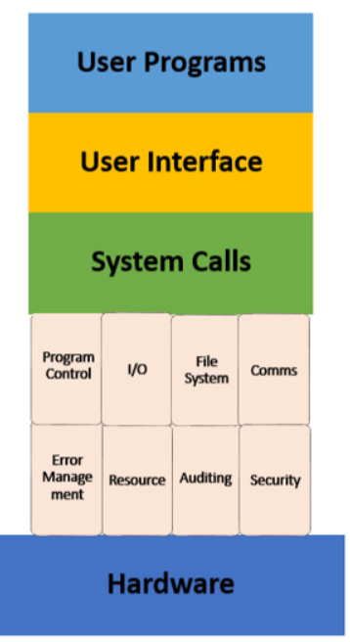

Example of System Call
For example if we need to write a program code to read data from one file, copy that data into another file. The first information that the program requires is the name of the two files, the input and output files.
In an interactive system, this type of program execution requires some system calls by OS.
- First call is to write a prompting message on the screen
- Second, to read from the keyboard, the characters which define the two files.

How System Call Works?
Here are the steps for System Call in OS:
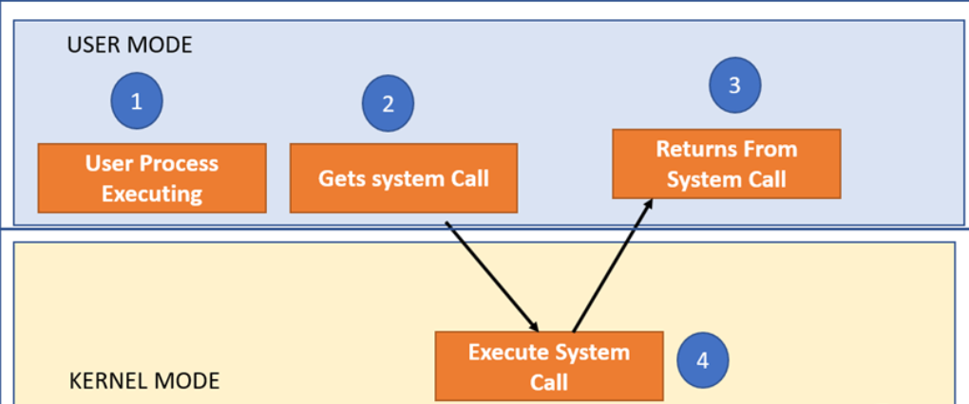
As you can see in the above-given System Call example diagram.
Step 1) The processes executed in the user mode till the time a system call interrupts it.
Step 2) After that, the system call is executed in the kernel-mode on a priority basis.
Step 3) Once system call execution is over, control returns to the user mode.,
Step 4) The execution of user processes resumed in Kernel mode.

Why do you need System Calls in OS?
Following are situations which need system calls in OS:
- Reading and writing from files demand system calls.
- If a file system wants to create or delete files, system calls are required.
- System calls are used for the creation and management of new processes.
- Network connections need system calls for sending and receiving packets.
- Access to hardware devices like scanner, printer, need a system call.

Types of System calls
Here are the five types of System Calls in OS:
- Process Control
- File Management
- Device Management
- Information Maintenance
- Communications
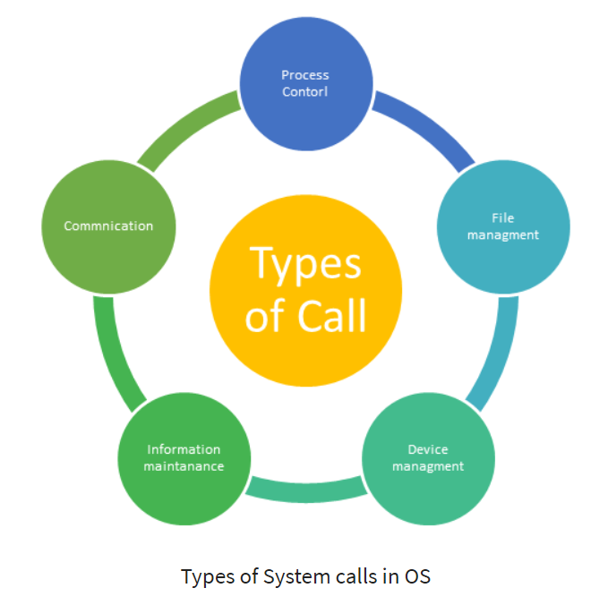

Process Control
This system calls perform the task of process creation, process termination, etc.
Functions:
- End and Abort
- Load and Execute
- Create Process and Terminate Process
- Wait and Signal Event
- Allocate and free memory

File Management
File management system calls handle file manipulation jobs like creating a file, reading, and writing, etc.
Functions:
- Create a file
- Delete file
- Open and close file
- Read, write, and reposition
- Get and set file attributes

Device Management
Device management does the job of device manipulation like reading from device buffers, writing into device buffers, etc.
Functions:
- Request and release device
- Logically attach/ detach devices
- Get and Set device attributes

Information Maintenance
It handles information and its transfer between the OS and the user program.
Functions:
- Get or set time and date
- Get process and device attributes

Communication
These types of system calls are specially used for interprocess communications.
Functions:
- Create, delete communications connections
- Send, receive message
- Help OS to transfer status information
- Attach or detach remote devices

Rules for passing Parameters for System Call
Here are general common rules for passing parameters to the System Call:
- Parameters should be pushed on or popped off the stack by the operating system.
- Parameters can be passed in registers.
- When there are more parameters than registers, it should be stored in a block, and the block address should be passed as a parameter to a register.

Important System Calls Used in OS

wait()
In some systems, a process needs to wait for another process to complete its execution. This type of situation occurs when a parent process creates a child process, and the execution of the parent process remains suspended until its child process executes.
The suspension of the parent process automatically occurs with a wait() system call. When the child process ends execution, the control moves back to the parent process.

fork()
Processes use this system call to create processes that are a copy of themselves. With the help of this system Call parent process creates a child process, and the execution of the parent process will be suspended till the child process executes.

exec()
This system call runs when an executable file in the context of an already running process that replaces the older executable file. However, the original process identifier remains as a new process is not built, but stack, data, head, data, etc. are replaced by the new process.

kill()
The kill() system call is used by OS to send a termination signal to a process that urges the process to exit. However, a kill system call does not necessarily mean killing the process and can have various meanings.

exit()
The exit() system call is used to terminate program execution. Specially in the multi-threaded environment, this call defines that the thread execution is complete. The OS reclaims resources that were used by the process after the use of exit() system call.

Summary
Categories | Windows | Unix
Process control | CreateProcess()  ExitProcess()  WaitForSingleObject() | fork()  exit()  wait()
Device manipulation | SetConsoleMode()  ReadConsole()  WriteConsole() | loctl()  read()  write()
File manipulation | CreateFile()  ReadFile()  WriteFile()  CloseHandle() | Open()  Read()  write()  close!)
Information maintanence | GetCurrentProcessID()  SetTimer()  Sleep() | getpid()  alarm()  sleep()
Communication | CreatePipe()  CreateFileMapping()  MapViewOfFile() | Pipe()  shm_open()  mmap()
Protection | SetFileSecurity()  InitlializeSecurityDescriptor()  SetSecurityDescriptorGroup () | Chmod()  Umask()  Chown()

Monolithic vs Layered OS

Introduction
we will discuss two important architectures: monolithic and layered OS. We will also see what these are and the key differences between them.

What is a Monolithic Operating System?
In this operating system, all the major components of the OS are located in the kernel space( it is a computer program at the core of OS). The kernel controls all the major features like memory management, process management, file management, and device management. It is a straightforward and vintage operating system that was first introduced in 1970. It was then used for small work like batch processing and time-sharing. Now let's discuss its architecture.

There are mainly three layers in a monolithic operating system: hardware, application, and monolithic kernel. As discussed above, the kernel handles the OS services like CPU scheduling, memory management, etc. The application requests services from the kernel; system calls do it. When an application requests a service hardware address space, the application switches to the hardware address of the OS; these operating systems also have a high-level virtual interface over computer hardware. Now let's discuss what its advantages and disadvantages are:
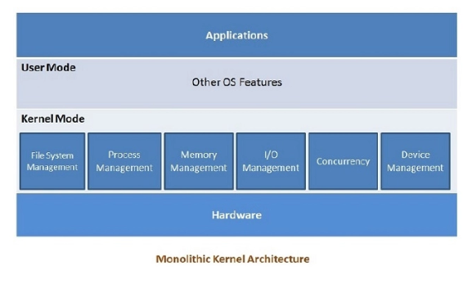

Advantages

Fast
Monolithic operating systems are fast. Thus, they provide better process scheduling, memory management, file management, etc.

Direct Interaction between Components
All the components and the kernel can directly interact. It also helps in gaining a better speed.

Easy and Simple
Its structure is easy and simple as all the components are located in the same address space.

Better for Smaller Tasks
Monolithic OS works better for handling smaller tasks.

Disadvantages

Prone to Errors
Monolithic OS can generate errors and bugs in the system. It is because user programs use the same address space as the kernel.

Difficult to Update
In monolithic OS, all the OS code is in a single big chunk; therefore, it is difficult to add or remove features in the OS.

Not Portable
The code written in monolithic OS is difficult to carry with or transfer to another system: this is because all the code works in a big chunk only, and you have to move it all.

What is a Layered Operating System?

As the name suggests, a layered operating system is an operating system with multiple layers. In the layered operating system, all layers exist separately to perform certain functionality, and modification in one layer does not affect other layers. The layered architecture was developed to overcome the limitations of the monolithic operating system.
Since layered architecture is more modulated, it is easier to create and update.
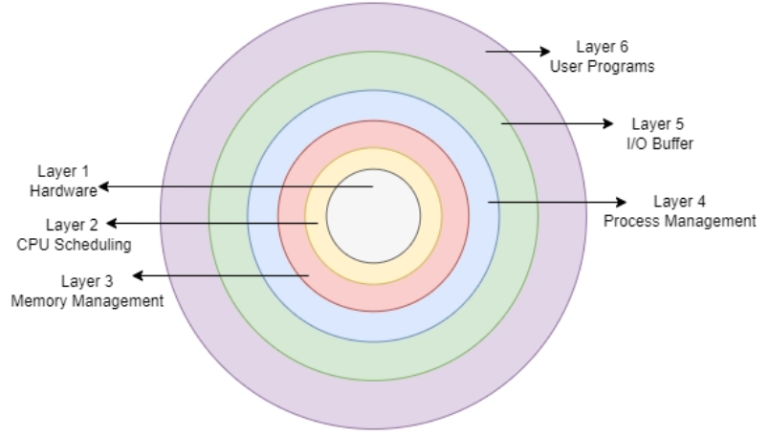
There are mainly six main layers in layered operating systems. These are:

Layer-1: Hardware
It is the lowest layer in the operating system architecture. The layer handles the hardware devices, where all the hardware devices are installed.

Layer-2: CPU Layer
All the tasks and CPU processes are scheduled in this layer.

Layer-3: Memory Management
The layer handles memory. It moves processes from the disk(secondary storage) to primary memory for execution and returns executed processes to the disk. The layer helps to utilize memory efficiently.

Layer-4: Process Management
The layer assigns the CPU to execute processes.

Layer-5: Input-Output Buffer
The layer provides an I/O device buffer and ensures that all the input-output devices work in synchronization. It allows the user to interact with the system.

Layer-6: User Programs
It is the highest layer in a layered operating system, and it is associated with the user programs like word processors, browsers, etc.
Now let’s discuss certain advantages and disadvantages of the layered OS:

Advantages

Modularity
The layered architecture is modular; therefore, it is easy to debug and update. Changes made to one layer do not affect the other layers.

Abstraction
The functions and implementations of each layer are abstract to each other. One layer is not concerned with the working of other layers and provides necessary input or output to the neighboring layers hiding their own implementation of working.

Easy Update
The modular system is easier to update. Only the layered which needs the update is worked on, and related code is modified. This doesn’t affect other layers, and no changes are required there.

Easy Debugging
The discrete layers are quite easy to debug. If any sort of error occurs in the memory or scheduling layer, then the concerned layers can be debugged.

Disadvantages

Slower in Execution
Layered OS is slow compared to monolithic OS. When a request is sent from one layer to another, it must traverse all the layers between the two, which increases the response time.

Complex Implementation
The layered architecture is somewhat complex, where a layer can utilize the services of the layers below it. And the requested layer should be able to provide the requested services.

Performance Degradation
In layered OS, too many layers are present which degrades the performance of the system.

Monolithic VS Layered Operating System
As we have discussed above, in monolithic OS architecture, the entire OS works in the kernel space, whereas in layered OS architecture, the operating system is divided into several independent layers having specific functionality. The differences can be summarized into two main points:
- A monolithic OS is one complete operating system that operates in kernel space, whereas a layered OS is divided into several layers, each layer serving a specific task.
- There are mainly three layers in a monolithic operating system, but a layered operating system has multiple layers(mainly six, we have discussed the six above in this article).
Parameter | Monolithic Operating System | Layered Operating System
Working | Complete operating system operating in kernel space. | The operating system is divided into several layers, each performing a specific task.
Number of Levels | Mainly, three layers are present. | Multiple layers are present in layered os.
Modularity | In monolithic OS, all the components and the kernel can directly interact, making it less modular. | The layered architecture is modular; therefore, it is easy to debug and update.
Modification and Updates | These are difficult to modify and update because all the code needs to be recompiled again after a minor update. | These are easier to update since the code of the concerned layer needs to be modified only.

Frequently Asked Questions

What is a microkernel?
A microkernel is one of the classifications of the kernel that manages all the system resources. It provides a bare minimum of the software to start an operating system. In this user and kernel, services are implemented in different address spaces.

Is LINUX monolithic or layered?
Linux and other UNIX systems are considered monolithic kernels. It is because all the functionalities are compiled into one big chunk of code.

Are monolithic kernels faster?
Monolithic kernels are much faster when compared to microkernels or other OS. It is because all the instructions run in the same address space, which makes the execution faster.

